Vocabulary – Level A

dans |  | un crayon
sur |  | une trousse
à côté |  | un taille-crayon
sous |  | un agenda
un sac |  | une gomme
une chaise |  | une règle
un ordinateur |  | des ciseaux
un bureau |  | noir
une porte |  | bleu
un sol |  | brun
une fenêtre |  | vert
un livre |  | gris
un crayon couleur |  | orange
un feutre |  | rose
une colle |  | violet
un cahier |  | rouge
un stylo |  | blanc
 |  | jaune

Silence !
Ferme la porte.
Ne rigolez pas.
Regardez à la page 20.
Ouvre la fenêtre.
Prends ton stylo.
pose ton livre.

Grammar – Level A

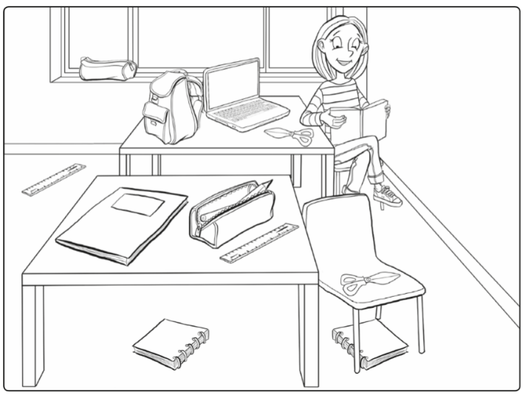
1. Answer the questions.
Where is the bag ?

Where is the pencil case ?

Where are the notebooks ?

Where is the pen ?

2. Read « Sunday morning » (SB, p.41), then without your SB, write a short text for each picture.
a.)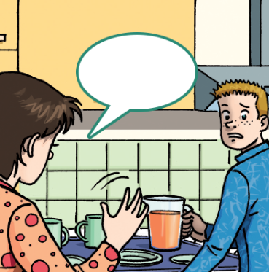 b.)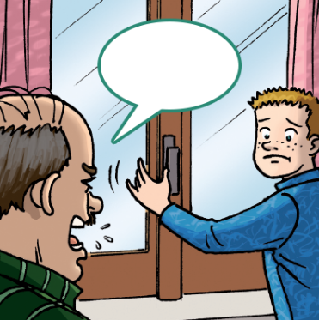 c.)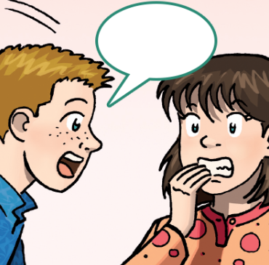 d.)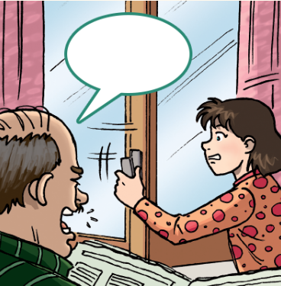 e.)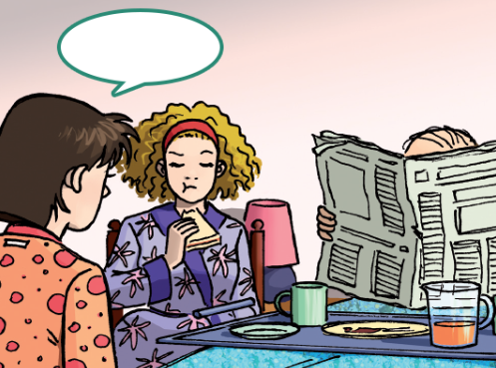
a.)
b.)
c.)
d.)
e.)

3. You have the answers, ask the questions. Start the questions with an interrogative word (all different).
? My book is on the floor.
? Michael is my brother.
? This is my pencil case.
? Because it’s Saturday.
? I’m fine, thank you.
Vocabulary – Level B

in |  | a pencil
on |  | a pencil case
next to |  | a pencil sharpener
under |  | a planner
a bag |  | a rubber
a chair |  | a ruler
a computer |  | scissors
a desk |  | black
a door |  | blue
a floor |  | brown
a window |  | green
a book |  | grey
a coloured pencil |  | orange
a felt tip pen |  | pink
a glue stick |  | purple
a notebook |  | red
a pen |  | white
 |  | yellow

Be quiet !
Close the door.
Don’t laugh !
Look at page 20.
Open the window.
Pick up your pen.
Put down your book.

Grammar – Level B

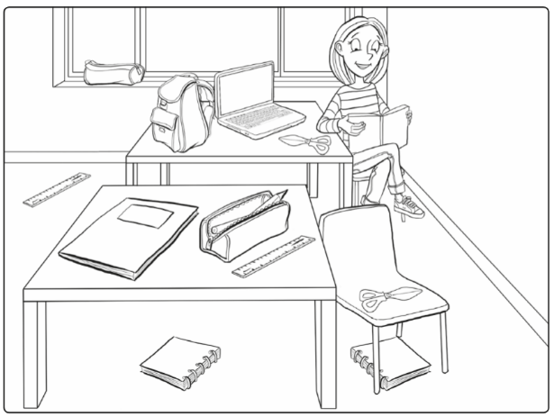
1. Complete and colour.

The pink bag is …..…..…. the desk.
The pencil case …….…… the window and it’s blue.
The notebooks are ……..… the ……....… and the table.
The green pen is ……….... the pencil case. It’s yellow.

2. Read « Sunday morning » at page 41 in your SB, then without your SB, choose the right text for each picture.
a.) b.) c.) d.) e.)

a.) They’re tired, make the breakfast ! / They’re angry, make the breakfast ! / They’re hungry,…
b.) She’s hot, open the window ! / She’s hot, close the window ! / She’s hot, open the door!
c.) He’s scared, where is the newspaper ? / He’s sad, where is… ? / He’s bored, where is… ?
d.) She’s cold, open the window ! / She’s cold, close the window ! / She’s tired, close the … !
e.) Are you happy now ? / Are you nervous now ? / Are you excited now ?

3. Complete with an interrogativ word.
is your book ? My book is on the floor.
is Michael ? Michael is my brother.
is this ? This is my pencil case.
are you happy ? Because it’s Saturday.
are you? I’m fine, thank you.
Vocabulary – Level C

dans | in / on | un crayon | a pen / a pencil
sur | in / on | une trousse | a pencil case / box
à côté | next to / under | un taille-crayon | a pencil sharpener
sous | next to / under | un agenda | a planner / a plan
un sac | a bag / a bug | une gomme | a ruber / a rubber
une chaise | a chair / a cher | une règle | a ruler / a rule
un ordinateur | a computer / a ordi | des ciseaux | scissors / sicors
un bureau | a pult / a desk | noir | white / black
une porte | a window / a door | bleu | blue / blu
un sol | a floor / a down | brun | bron / brown
une fenêtre | a window / a door | vert | green / grey
un livre | a bouk / a book | gris | green / grey
un crayon couleur | a coloured pencil | orange | orange / orenge
un feutre | a felt tip pen /pencil | rose | punk / pink
une colle | a glue stick / pen | violet | purple / purpel
un cahier | a notebook / a heft | rouge | red / raid
un stylo | a pen / a pencil | blanc | white / black
 |  | jaune | gelb / yellow

Silence ! Be quiet ! / Don’t laugh !
Ferme la porte. Close the door. / Open the window.
Ne rigolez pas. Be quiet. / Don’t laugh.
Regardez à la page 20. Look at page 20. / See at page 20.
Ouvre la fenêtre. Close the door. / Open the window.
Prends ton stylo. Pick up your pen / Put down your book.
pose ton livre. Pick up your pen / Put down your book.

Grammar – Level C

1. Colorie et complète avec les prépositions suivantes : on, in, under, next to.

The pink bag is …..…..…. the desk.
The pencil case …….…… the window and it’s blue.
The notebooks are ……..… the chair and the table.
The green pen is ……….... the pencil case. It’s yellow.

2. Lis le texte « Sunday morning » à la page 41 de ton SB. Ensuite, indique à quelle image chaque phrase appartient.
a.) b.) c.) d.) e.)

Are you happy now ?
He’s bored, where is the newspaper ?
She’s cold, close the window !
She’s hot, open the window !
They’re hungry, make the breakfast !

3. Complète en utilisant les mots interrogatifs donnés.
where what who how why
is your book ? My book is on the floor.
is Michael ? Michael is my brother.
is this ? This is my pencil case.
are you happy ? Because it’s Saturday.
are you? I’m fine, thank you.
Vocabulary – Level A

dans | in | un crayon | a pencil
sur | on | une trousse | a pencil case
à côté | next to | un taille-crayon | a pencil sharpener
sous | under | un agenda | a planner
un sac | a bag | une gomme | a rubber
une chaise | a chair | une règle | a ruler
un ordinateur | a computer | des ciseaux | scissors
un bureau | a desk | noir | black
une porte | a door | bleu | blue
un sol | a floor | brun | brown
une fenêtre | a window | vert | green
un livre | a book | gris | grey
un crayon couleur | a coloured pencil | orange | orange
un feutre | a felt tip pen | rose | pink
une colle | a glue stick | violet | purple
un cahier | a notebook | rouge | red
un stylo | a pen | blanc | white
 |  | jaune | yellow

Silence ! Be quiet !
Ferme la porte. Close the door.
Ne rigolez pas. Don’t laugh !
Regardez à la page 20. Look at page 20.
Ouvre la fenêtre. Open the window.
Prends ton stylo. Pick up your pen.
pose ton livre. Put down your book.

Grammar – Level A

1. Answer the questions.
Where is the bag ? The bag is on the desk.
Where is the pencil case ? The pencil case next to the window.
Where are the notebooks ? The notebooks are under the chair and the table.
Where is the pen ? The pen is in the pencil case.

2. Read « Sunday morning » (SB, p.41), then without your SB, write a short text for each picture.
a.) b.) c.) d.) e.)
a.) They’re hungry, make the breakfast !
b.) She’s hot, open the window !
c.) He’s bored, where ist he newspaper ?
d.) She’s cold, close the window !
e.) Are you happy now ?

3. You have the answers, ask the questions. Start the questions with an interrogative word (all different).
Where is your book ? My book is on the floor.
Who is Michael ? Michael is my brother.
What is this ? This is my pencil case.
Why are you happy ? Because it’s Saturday.
How are you? I’m fine, thank you
Vocabulary – Level B

in | dans | a pencil | un crayon
on | sur | a pencil case | une trousse
next to | à côté | a pencil sharpener | un taille-crayon
under | sous | a planner | un agenda
a bag | un sac | a rubber | une gomme
a chair | une chaise | a ruler | une règle
a computer | un ordinateur | scissors | des ciseaux
a desk | un bureau | black | noir
a door | une porte | blue | bleu
a floor | un sol | brown | brun
a window | une fenêtre | green | vert
a book | un livre | grey | gris
a coloured pencil | un crayon couleur | orange | orange
a felt tip pen | un feutre | pink | rose
a glue stick | une colle | purple | violet
a notebook | un cahier | red | rouge
a pen | un stylo | white | blanc
 |  | yellow | jaune

Be quiet ! Silence !
Close the door. Ferme la porte.
Don’t laugh ! Ne rigolez pas.
Look at page 20. Regardez à la page 20.
Open the window. Ouvre la fenêtre.
Pick up your pen. Prends ton stylo.
Put down your book. pose ton livre.

Grammar – Level B

1. Complete and colour.
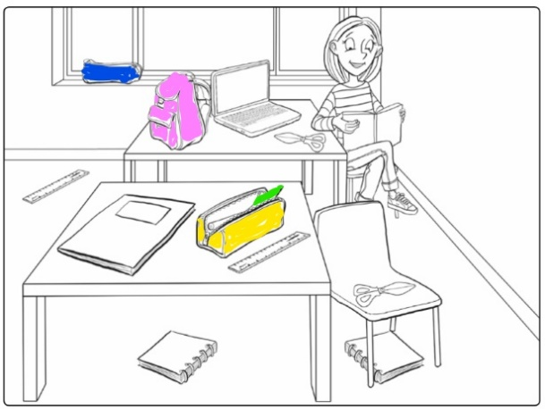
The pink bag is on the desk.
The pencil case is next to the window and it’s blue.
The notebooks are under the chair and the table.
The green pen is in the pencil case. It’s yellow.

2. Read « Sunday morning » at page 41 in your SB, then without your SB, choose the right text for each picture.
a.) b.) c.) d.) e.)

a.) They’re tired, make the breakfast ! / They’re angry, make the breakfast ! / They’re hungry,…
b.) She’s hot, open the window ! / She’s hot, close the window ! / She’s hot, open the door!
c.) He’s scared, where is the newspaper ? / He’s sad, where is… ? / He’s bored, where is… ?
d.) She’s cold, open the window ! / She’s cold, close the window ! / She’s tired, close the … !
e.) Are you happy now ? / Are you nervous now ? / Are you excited now ?

3. Complete with an interrogativ word.
Where is your book ? My book is on the floor.
Who is Michael ? Michael is my brother.
What is this ? This is my pencil case.
Why are you happy ? Because it’s Saturday.
How are you? I’m fine, thank you.
Vocabulary – Level C

dans | in / on | un crayon | a pen / a pencil
sur | in / on | une trousse | a pencil case / box
à côté | next to / under | un taille-crayon | a pencil sharpener
sous | next to / under | un agenda | a planner / a plan
un sac | a bag / a bug | une gomme | a ruber / a rubber
une chaise | a chair / a cher | une règle | a ruler / a rule
un ordinateur | a computer / a ordi | des ciseaux | scissors / sicors
un bureau | a pult / a desk | noir | white / black
une porte | a window / a door | bleu | blue / blu
un sol | a floor / a down | brun | bron / brown
une fenêtre | a window / a door | vert | green / grey
un livre | a bouk / a book | gris | green / grey
un crayon couleur | a coloured pencil | orange | orange / orenge
un feutre | a felt tip pen /pencil | rose | punk / pink
une colle | a glue stick / pen | violet | purple / purpel
un cahier | a notebook / a heft | rouge | red / raid
un stylo | a pen / a pencil | blanc | white / black
 |  | jaune | gelb / yellow

Silence ! Be quiet ! / Don’t laugh !
Ferme la porte. Close the door. / Open the window.
Ne rigolez pas. Be quiet. / Don’t laugh.
Regardez à la page 20. Look at page 20. / See at page 20.
Ouvre la fenêtre. Close the door. / Open the window.
Prends ton stylo. Pick up your pen / Put down your book.
pose ton livre. Pick up your pen / Put down your book.

Grammar – Level C

1. Colorie et complète avec les prépositions suivantes : on, in, under, next to.
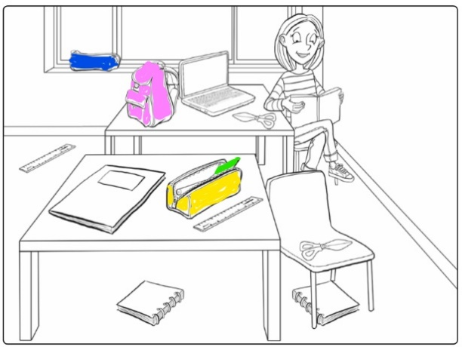
The pink bag is on the desk.
The pencil case next to the window and it’s blue.
The notebooks are under the chair and the table.
The green pen is in the pencil case. It’s yellow.

2. Lis le texte « Sunday morning » à la page 41 de ton SB. Ensuite, indique à quelle image chaque phrase appartient.
a.) b.) c.) d.) e.)

Are you happy now ? e
He’s bored, where is the newspaper ? c
She’s cold, close the window ! d
She’s hot, open the window ! b
They’re hungry, make the breakfast ! a

3. Complète en utilisant les mots interrogatifs donnés.
where what who how why
Where is your book ? My book is on the floor.
Who is Michael ? Michael is my brother.
What is this ? This is my pencil case.
Why are you happy ? Because it’s Saturday.
How are you? I’m fine, thank you.

